Alumni Tracker with Job Matching using AI Integration

**Author - Eduard Rino Q. Carton**

**Abstract -** In this study, an Alumni Tracker with Job Matching system was developed, incorporating Artificial Intelligence (AI) integration. The system analyzes data on alumni's education, work experience, skills, and preferences to offer personalized job recommendations. An iterative approach and Agile methodology were employed for system design, development, testing, deployment, and maintenance. AI algorithms, such as Hybrid Filtering, Collaborative Filtering, User Based Content Filtering, and NLP, were utilized to create an effective job matching system. The system's evaluation based on the ISO 25010 Software Quality Model criteria revealed that it fulfilled the requirements for reliability, usability, maintainability, security, compatibility, and functional suitability. Setting itself apart from other alumni tracker systems, the Alumni Tracker with Job Matching using AI Integration system provides personalized job recommendations and real-time information on job openings. The study concludes that integrating AI into the Alumni Tracker system is highly effective and beneficial for managing alumni data, offering personalized job recommendations through AI job matching and NLP algorithms, and generating comprehensive reports for alumni, employers, employment rates, and job postings

**Keywords:** *Alumni Tracker, Artificial Intelligence (AI), Job Matching, NLP Algorithm*

**Introduction**

Artificial intelligence (AI) has had a profound impact on various domains, including the job market (Makridakis, 2017). According to Jaiswal et al. (2021), an Alumni Tracker system provides a centralized platform for managing alumni data and facilitates communication between alumni and the institution Bista et al. (2021). By integrating AI algorithms, the Alumni Tracker with Job Matching system provides personalized job recommendations based on alumni's skills and qualifications. This system keeps alumni informed about current job market trends, offers real-time information on job openings, and effectively matches alumni with suitable job opportunities, benefiting both alumni and employers.

Design Plan & Software Development

The researcher used the iterative approach, which is a methodology that involves breaking a project into smaller parts and completing those parts in an iterative process, constantly reviewing and refining the work as needed. This approach allows for greater flexibility and adaptability and can help catch errors early on, ultimately leading to a higher-quality final product.

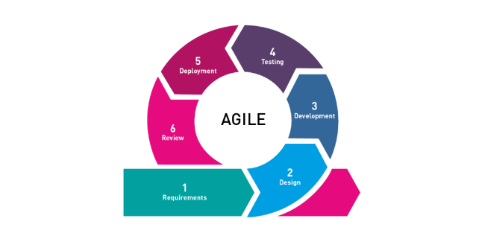

**Figure 1. Agile Software Development**

The Agile methodology focuses on providing value to end-users and prioritizes collaboration, flexibility, and continuous improvement. The model has five phases: Requirements, Design, Development, Testing, Deployment, and Review. The project utilizes AI algorithms to develop an effective job-matching system, including Hybrid Filtering, Collaborative Filtering, User-Based Content Filtering, and NLP algorithms.

**Software Life Cycle Model**

**Requirements Gathering**. In this phase, the researcher needs to identify the specific requirements for the software development project. One crucial requirement is the need for a large amount of data related to job postings, job requirements, job preferences, and alumni data. This data will be used to train and improve the AI algorithms used in the system, particularly Hybrid Filtering, Collaborative Filtering, User-Based Content filtering, and NLP algorithms.

**Design**. In this phase, the overall design of the software is created, including the architecture, user interface, and database schema. The design should be capable of incorporating the AI algorithms identified in the previous phase, with appropriate data sources and integration of the algorithms to ensure good job matching.

**Development**. In the development phase, the project team will work with the datasets to develop and test the AI algorithms. The data will be used to train the algorithms to identify patterns and relationships between job postings and alumni data. The team will use techniques such as supervised and unsupervised learning to ensure that the algorithms can accurately match alumni with relevant job opportunities.

**Testing**. In this phase, the software is tested to ensure that it meets the requirements and is error-free. The AI Expert should test AI algorithms to ensure they function effectively and provide accurate job-matching results.

**Deployment**. The software is deployed to the production environment in this phase. The AI algorithms should be integrated and fully operational within the system, ready to provide job-matching services to alumni.

**Maintenance**. The software is maintained and updated as needed in this phase. The researcher should continuously monitor the AI algorithms to ensure they provide accurate job-matching results and update them as necessary to improve their performance.

**Context Flow Diagram**

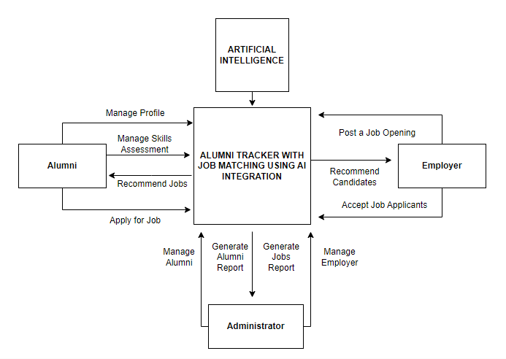

**Figure 2. Context Flow Diagram**

Figure 2 illustrates the researcher's depiction of how the complete features and components of the system will collaborate in alignment with its intended function. This figure has three main external entities: alumni, administrators, and employers. The integration of Artificial Intelligence.

**Application Architecture**

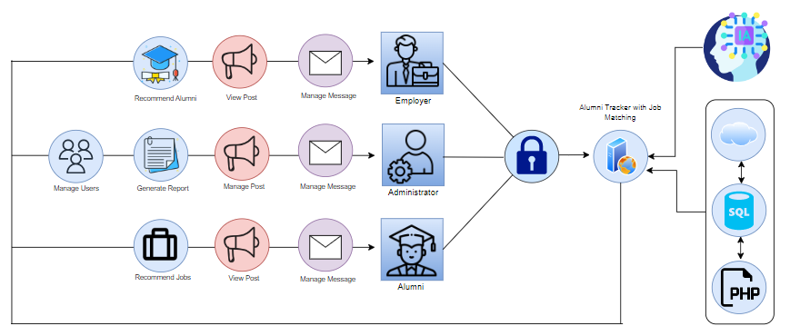

**Figure 3. Application Architecture**

Figure 3 showcases the operational dynamics of the system when utilized by registered users. In this architecture, the system is built around a web server, which serves as the entry point for incoming requests. The Job Portal component handles requests from alumni and job seekers, allowing them to view job postings and apply for relevant positions. The Job Matching Module processes incoming job applications and uses AI algorithms to match alumni with relevant job postings. The Alumni Tracker Module is responsible for managing the data and profiles of alumni, including their personal and professional information. The AI Engine component provides the computing resources needed to run the AI algorithms used in the system.

Results

After the comprehensive evaluation involving experts and respondents, the following are discovered:

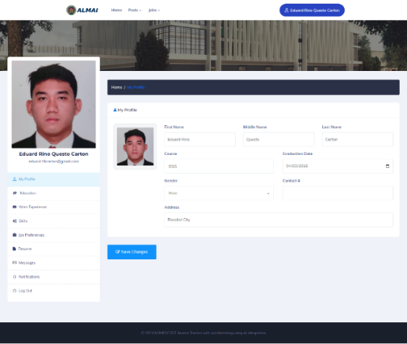

**Figure 4. Alumni’s Profiles**

Figure 4 shows how the alumni can manage their own profiles on the Alumni Tracker with Job Matching using AI Integration. The alumni can update his personal records, which generates an Alumni report.

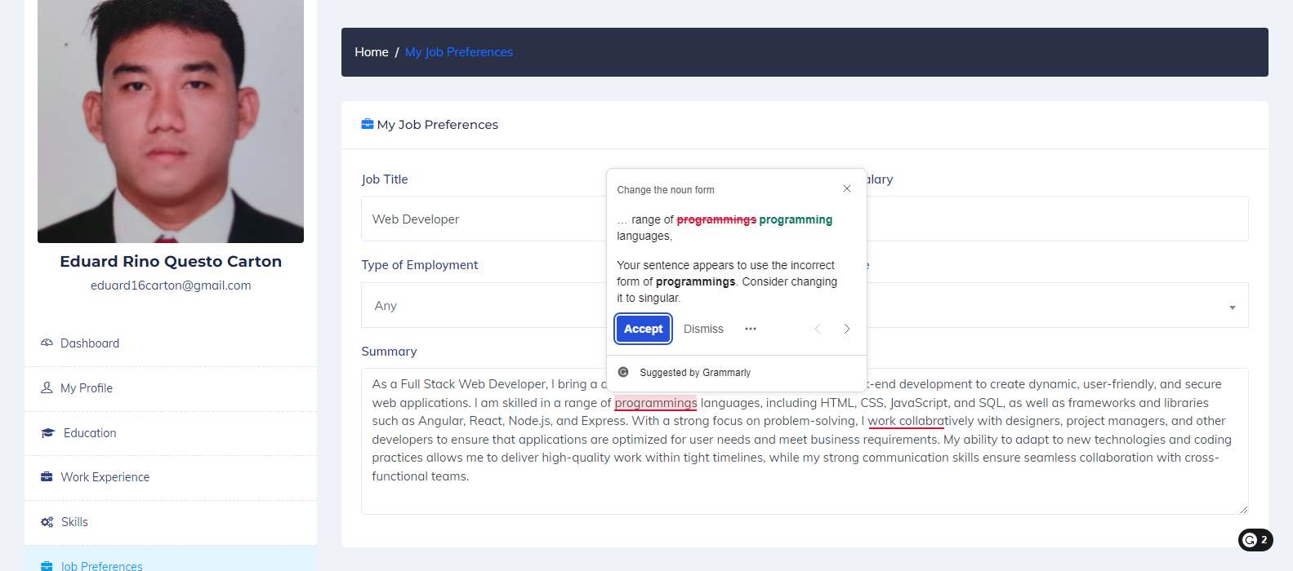

**Figure 5. Alumni Job Preferences with AI**

Figure 5 depicts the presentation of alumni job preferences with AI within the Alumni Tracker with Job Matching, incorporating AI Integration. Alumni can manage their job preferences using this system, and it also utilizes Natural Language Processing to analyse text and offer suggestions. This feature assists alumni in refining their job preferences and optimizing their job search experience.

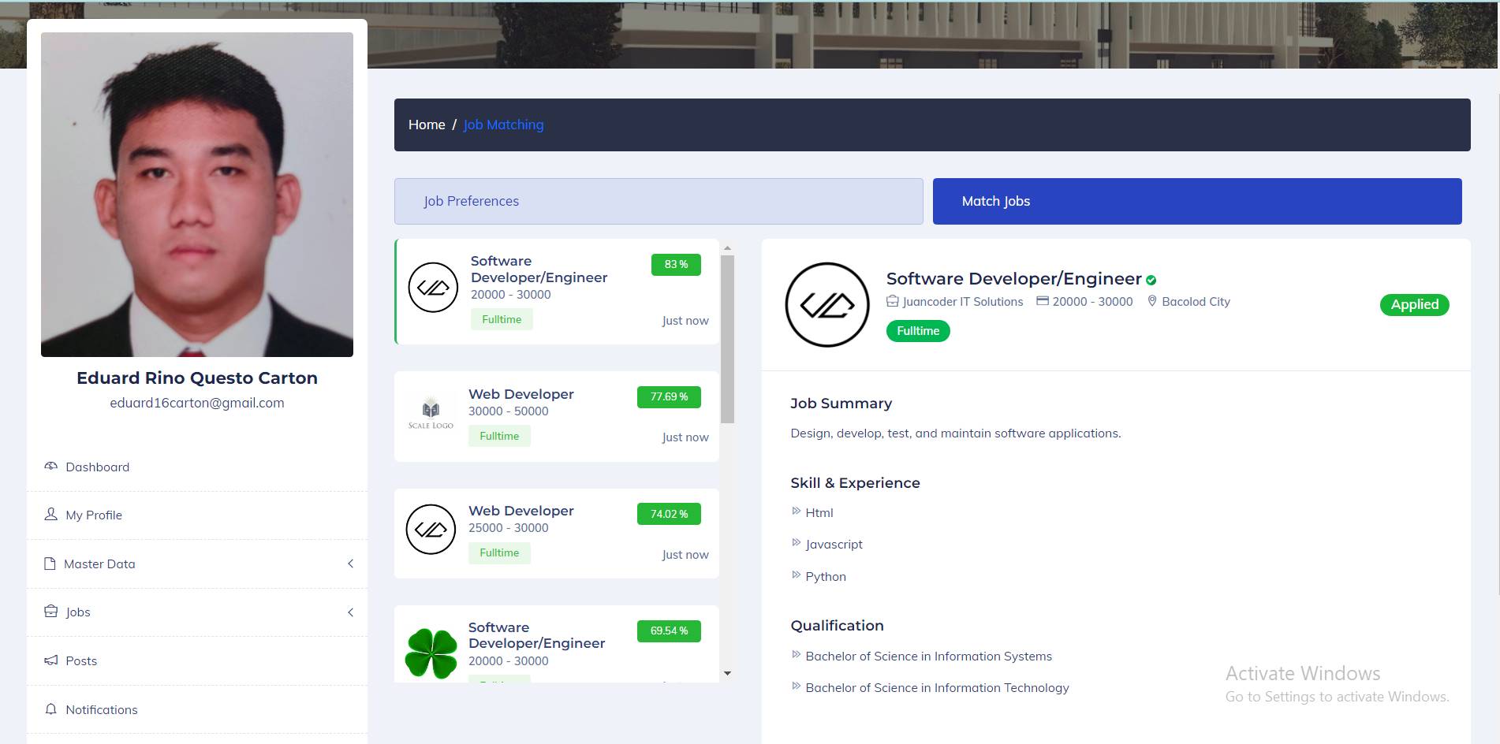

**Figure 6. Best Match Jobs**

Figure 6 illustrates Alumni best matched jobs within the Alumni Tracker with Job Matching, utilizing AI Integration. Alumni can access this feature to view job opportunities that align with their job preferences. The matched jobs are presented with a percentage indicator, indicating the compatibility between the alumni's preferences and the job requirements.

**Table 1.0**

**Evaluation Result given by the Respondent**

|  |  |  |
| --- | --- | --- |
|  | Mean | Verbal Interpretation |
| In terms of managing alumni’s data | 4.36 | Very Good |
| In terms of integrating AI using Job Matching Algorithm | 4.35 | Very Good |
| In terms of integrating AI using NLP Algorithm | 4.38 | Very Good |
| In terms of generate reports | 4.21 | Very Good |
| Total | 4.33 | Very Good |

Table 1 showed that the developed system is efficient in integrating AI in Alumni Tracker with Job Matching thus, the respondents rated the system with a grand mean of 4.33 interpreted as very good. In terms of managing alumni’s data, the system got a rating of 4.36. In terms of integrating AI using Job Matching and NLP Algorithm received a mean rating of 4.35 and 4.38, while in terms of generating report the system got a mean value of 4.21.

**In terms of managing alumni’s data**

The feedback indicates that the system allows alumni to utilize and access it effectively and manage their profiles, education history, work experience, skills assessment, and job preferences.

**In terms of integrating AI using Job Matching Algorithm**

The feedback indicates that the system enables alumni to effectively utilize and access it, view the best jobs that align with their preferences, and allow employers to view the best candidates.

**In terms of integrating AI using NLP Algorithm**

The feedback indicates that the system effectively provides access and usability for alumni, employers, and admins, allowing them to view the analyzed text and suggestions generated by AI.

**In terms of generating reports**

The feedback indicates that the system effectively equips access and usability for the admin, enabling them to generate reports for alumni per batch, alumni per college, alumni per program, employer per industry, job posting per year, and job posting per month.

**Table 2.0**

**Evaluation Result given by Experts**

|  |  |  |
| --- | --- | --- |
| Criteria | Mean | Verbal Interpretation |
| Functional Suitability | 5 | Very Good |
| Performance Efficiency | 5 | Very Good |
| Compatibility | 4.66 | Very Good |
| Usability | 4.33 | Good |
| Reliability | 5 | Very Good |
| Security | 4.66 | Very Good |
| Maintainability | 5 | Very Good |
| Portability | 4.66 | Very Good |
| Total | 4.79 | Very Good |

Table 2.0 presents the feedback from experts, evaluating the quality of the Alumni Tracker with Job Matching using AI Integration based on the characteristics defined in the ISO 25010 Software Quality Model.

In terms of Functional Suitability, Performance Efficiency, Reliability, and Maintainability, it received a mean value rating of 5, indicating a "Very Good" level. Similarly, it achieved a mean value rating of 4.66, also classified as "Very Good", for Compatibility, Security, and Portability. However, in terms of Usability, it received a mean value rating of 4.33, which denotes a "Good" level of usability.

In terms of Functional Suitability, the Alumni Tracker with Job Matching using AI Integration provides a wide range of functionalities that allow educational institutions to monitor the career development of alumni, provide career resources, and gather data to enhance the efficacy of programs and services while maintaining alumni engagement. The integration of AI algorithms in the development of the system enables alumni to find personalized job recommendations based on their skills and qualifications.

In terms of Performance efficiency, the system uses AI algorithms to analyze alumni data and provide personalized job recommendations, ensuring that job seekers find opportunities that match their qualifications and skills. The system's efficient algorithms ensure that the job recommendation process is fast and accurate, enabling alumni to find job opportunities quickly.

In terms of security, the system ensures the security of alumni data by using encryption and secure servers to protect the data. Additionally, the system requires authentication to access sensitive information, ensuring that only authorized users can access the data.

The reliability of Alumni Tracker with Job Matching using AI Integration is guaranteed through AI algorithms that provide accurate and personalized job recommendations while also allowing for bug reporting. The user-friendly interface and up-to-date information provided to alumni ensure the system meets the usability criterion. The system's use of AI algorithms also ensures maintainability, allowing developers to update the system to adapt to changes in the job market. Additionally, the system is highly portable and compatible with different web browsers and operating systems, meeting the portability and compatibility criteria, respectively.

Conclusion

In conclusion, the study's findings indicate that the incorporation of AI into the Alumni Tracker system for NONESCOST has demonstrated remarkable effectiveness and significant benefits. The evaluation conducted by both experts and respondents confirms the system's ability to successfully manage alumni data, offer personalized job recommendations through AI job matching and NLP algorithms, and generate comprehensive reports for various stakeholders. The system's performance has been consistently rated as very good, reflecting its reliability, usability, maintainability, portability, and compatibility according to the ISO 25010 software quality model.

These results have significant implications for NONESCOST and its alumni community. The Alumni Tracker with Job Matching using AI Integration has the potential to enhance the connection between the institution and its alumni, facilitating seamless communication and engagement. Furthermore, the system empowers employers by providing an efficient platform to identify and connect with qualified candidates, thereby increasing the likelihood of successful job placements for alumni.

Recommendations

Based on the findings and conclusions, the following recommendations are proposed:

The Alumni Tracker with Job Matching using AI Integration should be implemented in other educational institutions across the Philippines to leverage its benefits and enhance alumni tracking and job matching capabilities.

Improve the notification mechanism to ensure timely and relevant communication between alumni, employers, and the system. This includes notifying alumni about matched job opportunities, notifying employers about the best candidate matches, and keeping all parties informed about important announcements.

Further, to enhance the effectiveness of the presented solution, it is recommended to conduct additional research and studies. These studies can focus on refining the Alumni Tracker with Job Matching using AI Integration, exploring potential areas of improvement, and evaluating its long-term impact on alumni career outcomes.

Conflicts of interest. The authors declare that for this article they have no actual, potential or perceived conflict of interests.

References

Ardiansyah, T. M. (2021). Web-Based Abulyatama Alumni Information System. International Journal Education and Computer Studies (IJECS), 1(2), 38–42. https://doi.org/10.35870/ijecs.v1i2.600

Bista, B., Shakya, A., Joshi, B., Pokhrel, A., Dangol, L., Kedia, M., & Baral, D. S. (2021). An Alumni Portal and Tracking System. Journal of the Institute of Engineering, 16(1), 7–14. https://doi.org/10.3126/jie.v16i1.36529

Hufana, M. C. S. (2019). An Alumni Tracer System for Saint Louis College. Ascendens Asia Journal of Multidisciplinary Research Conference Proceedings, 3(4).

Jaiswal, S., Gaud, S., Ansari, S., & Gaikwad, R. (2021). Alumni Tracking System. International Research Journal of Engineering and Technology (IRJET, 8(4), 1185-1188. doi: 10.31764/IRJET.8.4.1185

K. N. Prafajar, H. Vallyan, N. L. P. A. Candradewi, I. S. Edbert and D. Suhartono, "Multiclass Job Recommendation System in the IT Field between Classification and Prediction Method," 2022 International Conference on Green Energy, Computing and Sustainable Technology (GECOST), Miri Sarawak, Malaysia, 2022, pp. 181-186, doi: 10.1109/GECOST55694.2022.10010659.

Makridakis, S. (2017). Forecasting the Impact of Artificial Intelligence (AI). Foresight: The International Journal of Applied Forecasting, (47), 7-13. Retrieved from https://ideas.repec.org/a/for/ijafaa/y2017i47p7-13.html

Mona, E., Ranjani, H., Sowmya, V., & Sivakumari, S. S. (2021). Alumni Social Networking Site. International Journal of Scientific Research in Computer Science, Engineering and Information Technology, 6(1), 467.

Mukherjee, A., Roy, A., Lath, M. K., Ghosal, A., & Sengupta, D. (2019). Centralized Alumni Management System (CAMS) - A Prototype Proposal. In 2019 Amity International Conference on Artificial Intelligence (AICAI) (pp. 967-971). Dubai, United Arab Emirates: IEEE. doi: 10.1109/AICAI.2019.8701383

Patil, C., Patil, N., Kapse, K., Joshi, N., & Chavan, S. (2017). Alumni Interactive System Using Mining. International Journal of Engineering Science and Computing, 7(11).

Sadi, Lucitasari, D. R., & Khannan, M. S. A. (2019). Designing Mobile Alumni Tracer Study System Using Waterfall Method: an Android Based. International Journal of Computer Networks and Communications Security, 7(9), 196-202.

Safi'i, I., & Priyantoro, P. (2019). Tracer Study as an Effort to Improve Alumni Careers in Kadiri University Job Placement Service. KONSELI: Jurnal Bimbingan dan Konseling (E-Journal), 6(2).

Setyaningsih, R., Abdullah, A., Prihantoro, E., & Hustinawaty, H. (2022). DIGITAL SKILL: OPTIMIZING THE UTILIZATION OF INFORMATION TECHNOLOGY BY PESANTREN UNIVERSITY IN ALUMNI TRACKING ACTIVITIES. Proceedings of International Conference on Communication Science (ICCS), 2(1), Journalisim, ICT and Digital Media